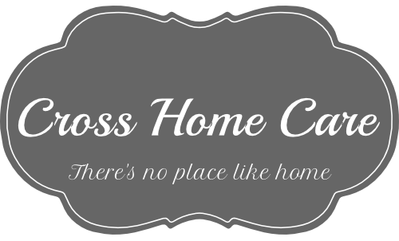
INFORMATION PACKET
WHAT IS HOME CARE?
Home Care is non-medical care provided by trained professionals that keeps people safe and as independent as possible in the comfort of their own home. Services provided includes:
- Medication Reminders
- Personal Care: Bathing, Grooming, Dressing, Toileting Assistance
- Transportation to appointments and other errands
- Meal Preparation and Diet Monitoring
- Much More! Go to www.CrossHomeCareLLC.com for more information

COSTS OF IN-HOME CARE VS. CONTINUING CARE
According to Seniorliving.org:
- Nursing Homes average $222 a day for a private room; $200 for a semi-private room.
- Assisted living facilities ("typically include at least two meals per day, housekeeping, and personal care assistance, were obtained for one-bedroom apartments or private rooms with private baths in assisted living communities.") average $3,300 a month.
- In-Home Care averages $19 an hour. We require a 2-hour minimum so the minimum cost is $38 daily!

COST OF SERVICES
All services require a two-hour minimum and are offered 24/7
$19/hour ($23/ hour for couples)
*Holidays cost 1 ½ times the regular hourly rate*
Recognized Holidays: New Year’s Day, Presidents Day, Easter, Memorial Day, 4th of July, Labor Day, Veteran’s Day, Thanksgiving Day, and Christmas Day
Accepted Medicaid Waivers: Aging (PDA), Attendant Care/ Act 150, COMMCARE, Independence, OBRA, and Community Health Waiver

WHY IN-HOME CARE?
Are you having difficulty with things that used to seem so simple or you might just want some company? Or maybe you are considering home care for a parent or spouse? At Cross Home Care, our highly-trained Caregivers are there to help with the difficult tasks. You tell us what you need done and we will be there for you.
If you are like most people, you would choose living at home for as long as possible compared to other alternatives like moving to an assisted living facility or a nursing home. Independence is something you have perfected your entire life and you shouldn’t give it up easily. This is why home care is an amazing option.
WHAT SEPARATES CROSS HOME CARE FROM THE REST?
Mission Statement: Our mission at Cross Home Care is to provide remarkably skilled staff in order to deliver the highest level of non-medical companion and personal care possible to keep seniors and adults with disabilities in their homes for as long as possible.

CAREGIVER TRAINING:
Cross Home Care’s employees pride themselves on the extensive training they have completed in order to provide the highest level of care possible. All Personal Care Providers are required to complete Annual Competency Training in the following areas:
Required By State: Additional Training:
Confidentiality | Caring for Stroke Patients
Consumer Control and The Independent Living Philosophy | Caring for ALS Patients
Instrumental Activities of Daily Living | Caring for people with Alzheimer’s
Recognizing Changes in The Consumer That Need to Be Addressed | The Importance of Strength Training for Elderly
Basic Infection Control | Recovering from a Fall
Universal Precautions | Fall Prevention
Handling of Emergencies | Preventing Pressure Ulcers
Documentation | Activities of Daily Living
Recognizing and Reporting Abuse 0r Neglect | Hospice Care
Dealing with Difficult Behaviors | Professionalism
Bathing, Shaving, Grooming and Dressing | Caring for the Blind and Visually Impaired
Hair, Skin and Mouth Care | Caring for the Hearing Impaired and Deaf
Assistance with Ambulation and Transferring | Caring for Patients with Parkinson’s
Meal Preparation and Feeding | Mobility for the Elderly
Toileting | Mental Health
Assistance with Self-Administered Medications | Brain and Nervous System
 | Lifting and Back Safety
 | Transfer and Positioning
 | Driver Safety Training
 | Nutrition Guidelines for Diabetics
 | Cerebral Palsy
 | Skin Care for Amputees

In addition, all caregivers are fully insured and bonded!

HIRING REQUIREMENTS FOR CAREGIVERS:
- High School Diploma or GED  - Reference Checks  - Drug Testing | - Criminal Background Check  - Annual Tuberculosis Screening  - CPR Certification  - Child Abuse Clearances | - The following verifications:  - Valid driver’s license  - Driving record review  - Working cell phone  - Valid registration  - Valid inspection  - Adequate auto insurance

